**Unit Testing Tools Result**

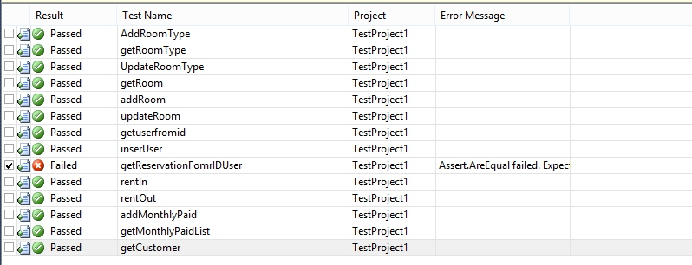

|  |  |  |  |
| --- | --- | --- | --- |
| **Unit Testing Tools** | | | |
| S. No | Conditions | Output | Pass/Failed |
| 1. | Admin do Rent In for customer. | (RentIn) The result will be passed. The auto-generate of ID Transaction works well. | Pass |
| 2. | Admin do Rent Out for customer | (RentOut) The result will be passed. | Pass |
| 3. | Admin do get Reservation from ID User | (getReservationFromIDUser)The result will be passed. | Failed |
| 4. | Admin do Update Room | (UpdateRoom) The result will be passed. | Pass |
| 5. | Admin View Room Type | (getRoomType) The result will be passed. | Pass |
| 6. | Admin do Add Room Type | (AddRoomType) The result will be passed. | Pass |
| 7. | Admin do Add Customer | (AddCustomer) The result will be passed. | Pass |
| 8. | Admin do Update Room Type | (UpdateRoomType) The result will be passed. | Pass |
| 9. | Customer Registration | (InsertUser) The result will be passed | Pass |
| 10. | Admin view the Room | (getRoom) The data will be shown in desktop app | Pass |
| 11. | Admin view the Customer | (getCustomer) The data will be shown in desktop app | Pass |

(Result of Unit Testing Tools)

|  |  |  |  |
| --- | --- | --- | --- |
| **Manual Tools** | | | |
| S. No | Conditions | Pass | Failed |
| 1. | The data will be saved if administrator entering customer data with valid parameter | Pass | - |
| 2. | The data will be shown in the text box if the administrator click the grid view column | Pass | - |
| 3. | The data will be edited if the administrator editing customer data | Pass | - |
| 4. | The transaction will be done if customer entering valid parameter | Pass | - |
| 5. | The transaction will be failed if customer entering invalid parameter (empty text field) | Pass | - |
| 6. | The transaction will be failed if customer entering invalid parameter | Pass | - |
| 7. | The transaction will be failed if customer cancelling transaction | Pass | - |
| 8 | The login will be failed if the customer input wrong email or password | Pass | - |
| 9 | The transactions will be failed if the account balance equals Rp. 25.000 | Pass | - |
| 10 | The customer could view the detail of all their monthly paid | Pass | - |
| 11 | The customer could reserve any room type | Pass | - |
| 12 | The login will be failed if the admin input wrong username and password. | Pass | - |
| 13 | Any Desktop Application has a rules in every input. | Pass | - |
| 14 | If customer do Reservation using function: public string AddReservation(object), with valid object | Pass | - |
| 15 | If customer view their reservation status using function: public List getReservationFromID(string id), with valid parameter | Pass | - |
| 16 | If customer view Room type using function: public List getRoomType(), without parameter | Pass | - |
| 17 | If customer do login using function: public List loginUser(string email,string password), with valid parameter | Pass | - |
| 18 | If admin view reservation status using function: public List getReservationFromID(string id), with valid parameter | Pass | - |
| 19 | If admin do rent in using function: void RentIn(), with valid object parameter | Pass | - |
| 20 | If admin do rent out using function: void RentOut(), with valid object parameter | Pass | - |
| 21 | If admin do add rent room using function: void AddRoom(), with valid object parameter | Pass | - |
| 22 | If admin do add room type using function: void AddRoomType(), with valid object parameter | Pass | - |
| 23 | If admin do add customer using function: void AddCustomer(), with valid object parameter | Pass | - |
| 24 | If admin do update customer in using function: void UpdateCustomer(), with valid object parameter | Pass | - |
| 25 | If admin do delete room using function: void DeleteRoom(), with valid object parameter | Pass | - |
| 26 | If admin do update room type in using function: void UpdateRoomType(), with valid object parameter | Pass | - |
| 27 | If admin do delete room type in using function: void DeleteRoomType(), with valid object parameter | Pass | - |
| 28 | If admin do monthly paid using function: void AddMonthlyPaid(), with valid object parameter | Pass | - |
| 29 | If admin view monthly paid in using function: void LoadMonthlyPaid() | Pass | - |